Prithvi Dhirwani
D15C 25
MLDL
Practical 4: Implementation of K-Nearest Neighbors (KNN) Algorithm

1. Dataset Source
The dataset used for this experiment is the Breast Cancer Wisconsin (Diagnostic) Dataset.
Dataset Link:
https://www.kaggle.com/datasets/uciml/breast-cancer-wisconsin-data

- 2. Dataset Overview
- The Breast Cancer Wisconsin dataset is a widely used medical dataset designed for binary classification tasks. Its purpose is to determine whether a breast tumor is malignant (cancerous) or benign (non-cancerous) based on quantitative measurements of cell nuclei.
- Dataset Characteristics
- Total Samples: 569
- Total Features: 30 numerical attributes
- Target Variable: diagnosis
- M → Malignant
- B → Benign
- Feature Information
- The features are extracted from digitized images of a Fine Needle Aspirate (FNA) of a breast mass. They describe characteristics of the cell nuclei, including:
- Radius
- Texture
- Perimeter
- Area
- Smoothness
- Compactness
- Concavity
- Symmetry
- Fractal dimension
- Each of these characteristics is computed as statistical measures such as mean value, standard error, and worst (maximum) value.

- 3. Mathematical Explanation of K-Nearest Neighbors (KNN)
- K-Nearest Neighbors (KNN) is a non-parametric, instance-based learning algorithm. It makes predictions based on similarity between data points.
- Distance Computation
- KNN determines similarity using a distance metric, most commonly Euclidean Distance:
- d(x, y) = √ Σ (xᵢ − yᵢ)²
- Where:
- x = test sample
- y = training sample
- n = number of features
- Classification Procedure
- Calculate the distance between the test point and all training points.
- Identify the K closest neighbors.
- Assign the class label based on majority voting among those K neighbors.

- 4. Limitations of KNN
- Computationally intensive for large datasets since all distances must be calculated.
- Model performance is highly dependent on the choice of K.
- Sensitive to noisy or irrelevant features.
- Requires feature scaling to ensure fair distance measurement.
- Performance degrades in high-dimensional spaces (curse of dimensionality).

- 5. Methodology / Workflow
- Implementation Steps
- Load the dataset
- Clean and preprocess the data
- Convert target labels into numerical form
- Apply feature scaling (Standardization)
- Split the dataset into training and testing sets
- Train the KNN classifier
- Generate predictions on the test set
- Evaluate classification performance
- Tune hyperparameters (optimal K value)
- Workflow Summary
- Dataset → Preprocessing → Feature Scaling → Train-Test Split
→ KNN Training → Prediction → Model Evaluation

- 6. Performance Evaluation
- The classifier was assessed using the following metrics:
- Accuracy
- Precision
- Recall
- F1-Score
- Confusion Matrix
- Observations
- KNN achieved strong accuracy in tumor classification.
- The model effectively differentiated between malignant and benign cases.
- Errors were significantly reduced after applying proper feature scaling.

- 7. Hyperparameter Optimization
- Tuned Parameter
- K (Number of Neighbors)
- Tuning Strategy
- Evaluated multiple K values (for example, from 1 to 20).
- Selected the value that provided the highest validation accuracy.
- Effect of Tuning
- Very small K values led to overfitting.
- Very large K values resulted in underfitting.
- Choosing an optimal K improved generalization and minimized prediction errors.

Code:
import pandas as pd
import matplotlib.pyplot as plt

from sklearn.model_selection import train_test_split
from sklearn.neighbors import KNeighborsClassifier
from sklearn.metrics import accuracy_score, confusion_matrix, classification_report
from sklearn.preprocessing import StandardScaler

# ===============================
# LOAD DATASET
# ===============================
df = pd.read_csv(
r"C:\Users\vrkha\Desktop\MLDL\breast_cancer.csv"
)

print(df.head())
print(df.shape)

# ===============================
# DATA CLEANING
# ===============================
# Drop unnecessary columns
df = df.drop(['id', 'Unnamed: 32'], axis=1)

# Encode target variable
df['diagnosis'] = df['diagnosis'].map({'M': 1, 'B': 0})

# ===============================
# FEATURES & TARGET
# ===============================
X = df.drop('diagnosis', axis=1)
y = df['diagnosis']

# ===============================
# FEATURE SCALING (VERY IMPORTANT FOR KNN)
# ===============================
scaler = StandardScaler()
X = scaler.fit_transform(X)

# ===============================
# TRAIN-TEST SPLIT
# ===============================
X_train, X_test, y_train, y_test = train_test_split(
X, y, test_size=0.2, random_state=42
)

# ===============================
# KNN CLASSIFIER
# ===============================
knn = KNeighborsClassifier(n_neighbors=5)
knn.fit(X_train, y_train)

y_pred = knn.predict(X_test)

# ===============================
# PERFORMANCE EVALUATION
# ===============================
print("\n--- KNN Classifier ---")
print("Accuracy:", accuracy_score(y_test, y_pred))
print("Confusion Matrix:\n", confusion_matrix(y_test, y_pred))
print("Classification Report:\n", classification_report(y_test, y_pred))

# ===============================
# ACCURACY vs K GRAPH
# ===============================
k_values = range(1, 21)
accuracy_list = []

for k in k_values:
model = KNeighborsClassifier(n_neighbors=k)
model.fit(X_train, y_train)
pred_k = model.predict(X_test)
accuracy_list.append(accuracy_score(y_test, pred_k))

plt.plot(k_values, accuracy_list, marker='o')
plt.xlabel("K Value")
plt.ylabel("Accuracy")
plt.title("KNN Accuracy for Different K Values")
plt.show()

OUTPUT:
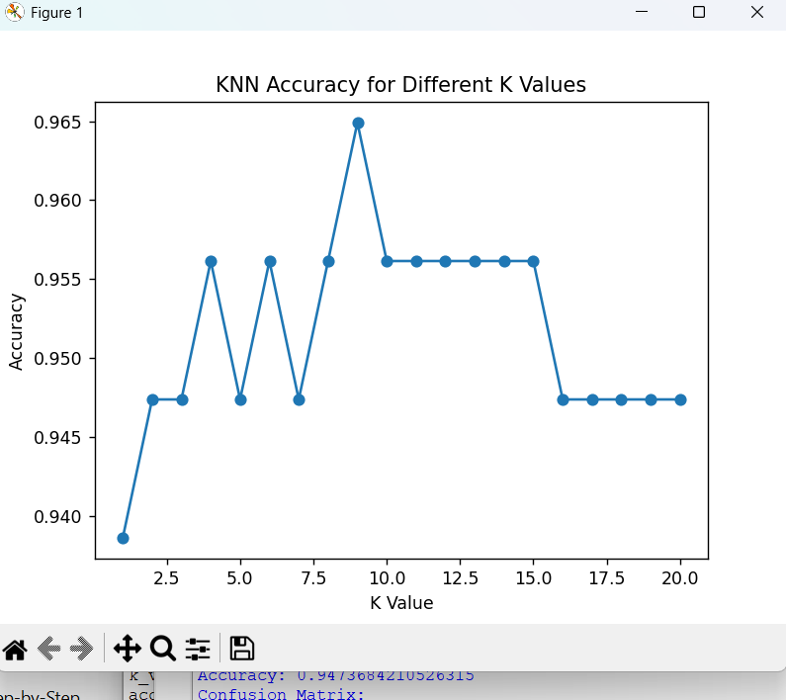
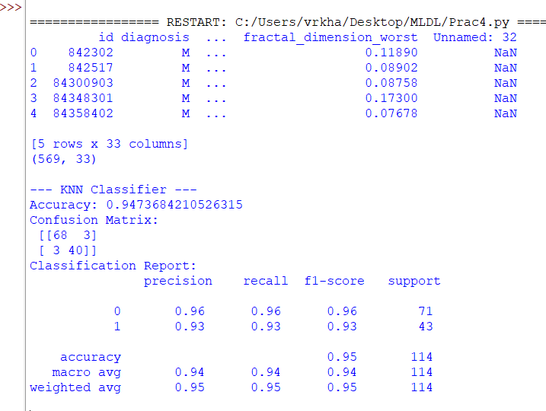
Conclusion
The K-Nearest Neighbors (KNN) algorithm effectively classified breast cancer tumors using real-world medical data. Careful data preprocessing, proper feature scaling, and optimal selection of hyperparameters notably enhanced the model’s accuracy and reliability. Overall, KNN demonstrates that despite its simplicity, it can deliver strong performance for classification problems, especially when working with moderately sized datasets.

